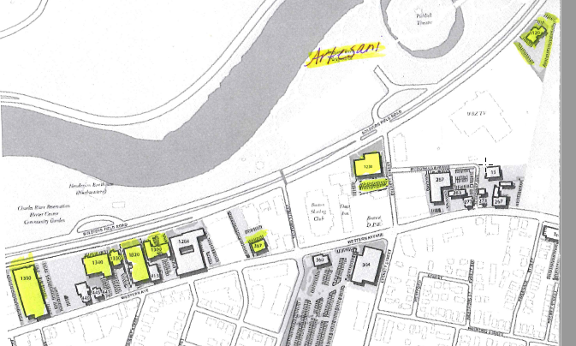

Alternate Parking when Artesani is full:

1120 Soldiers Field Rd

1230 Soldiers Field Rd

1300 Soldiers Field Rd

1320 Soldiers Field Rd

1330 Soldiers Field Rd

1340 Soldiers Field Rd

1380 Soldiers Field Rd



Alternate Parking when Artesani is full:

1120 Soldiers Field Rd

1230 Soldiers Field Rd

1300 Soldiers Field Rd

1320 Soldiers Field Rd

1330 Soldiers Field Rd

1340 Soldiers Field Rd

1380 Soldiers Field Rd